**Quantitative Biology Lab – April 22, 2022**

**1. Determining the order of reaction from half-lifes**

As we saw in class, the half-life (t1/2) of an elementary reaction can depend on the initial reactant concentration in ways that differ for each reaction order.

For a reaction in which compound A converts into a product, let’s say that you can measure the concentration of A ([A]) by measuring the absorbance of A at a wavelength of 340 nm, because none of the reaction products absorbs significantly at this wavelength.

Suggest an experimental strategy for determining the reaction order. The strategy should exploit the dependence of t1/2 on the initial concentration of A. You do not need to give every small detail, but outline the measurement(s) that you would do and how you would analyze the resulting data.

I would set up a reaction in a cuvette with a known concentration of A and immediately begin measuring the absorbance of the reaction. The resulting graph of absorbance over time should show a decrease, given that we expect A to be disappearing. At the time corresponding to half the initial absorbance, we can say that this is t­1/2 for that initial concentration.

Repeat the above for different initial concentrations of A, then plot concentration A versus t1/2. If this graph is linearly increasing, it is a zero-order reaction, if it is constant, it is first order, and if it is asymptotically decreasing to zero, then it is second order.

**2. Sequential reactions**

Many kinetic processes can be broken down into several elementary reactions. One example is a sequential reaction in which an intermediate is formed:

$$A \underset{→}{k_{1}} I \underset{→}{k_{2}} B$$

In this case, the conversion of A to B proceeds through an intermediate I.

1. Assuming that both steps in this reaction are first-order elementary reactions, plot concentration vs. time for A, I and B for [A]0 = 1 in the range of 0 ≤ t ≤ 25 seconds, using   
   k1 = 0.25 s-1 and k2 = 1 s-1.
2. Calculate and plot the concentrations for A, I and B for k1 = 1 s-1 and k2 = 0.25 s-1. How do the changes in concentration over time compare for each of the three species?

A exponentially decays while B increases in a seemingly logistic manner, approaching a final concentration equal to [A]0. Species I initially increases but then gradually decreases as it gets converted to B.

1. The plot below shows how the concentration of B changes for several combinations of k1 and k2. k1 is constant, whereas k2 varies. Why do the estimated half-lives for completion of the reaction given below only vary by a factor of less than 2, even though k2 varies by 2 orders of magnitude? (Rate constant units: 1/s, half-life units: s)  
   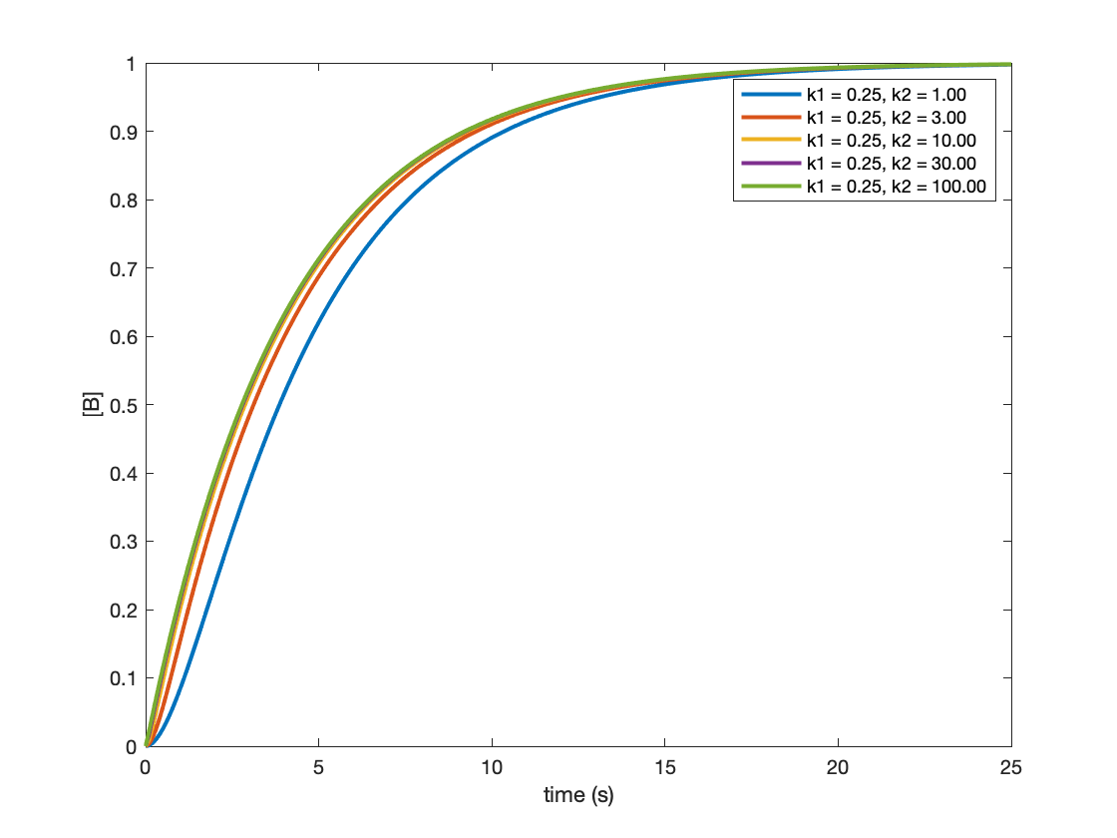  
    k1 = 0.25, k2 = 1.00, t_half = 3.9  
    k1 = 0.25, k2 = 3.00, t_half = 3.1  
    k1 = 0.25, k2 = 10.00, t_half = 2.9  
    k1 = 0.25, k2 = 30.00, t_half = 2.8  
    k1 = 0.25, k2 = 100.00, t_half = 2.8

This is because k1 is small, meaning that the A🡪I reaction is the rate limiting step of the overall reaction. Hence, as long as k2 is sufficiently large (which it is for all these examples), I🡪B will go relatively fast compared to the overall reaction as long as k1 is significantly lower than k2, and this means that the rate of the overall reaction, marked by the appearance of B, will be close to the rate of A🡪I with a rate constant of k1.

**3. Cyclophilin**

Cyclophilin A (CypA) is a peptidyl-prolyl isomerase (PPIase), an enzyme that catalyzes the isomerization of peptide bonds with proline. Cyclosporin (cs) is an inhibitor of CypA that binds the enzyme reversibly.

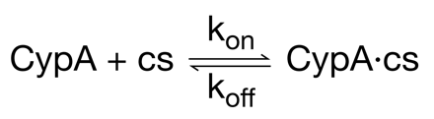

A tryptophane residue in CypA changes its fluorescence intensity when cyclosporin binds to the protein. When you mix cyclosporin and CypA, you can measure the binding kinetics by following the decrease of tryptophane fluorescence over time.

1. If you want to determine the off-rate, koff, what initial concentrations of CypA, [CypA]0, and cyclosporin, [cs]0, would you choose for such a measurement? Select one answer and explain your reasoning.  
     
   A. [CypA]0 << [cs]0, vary [CypA]0  
   **B. [CypA]0 << [cs]0, vary [cs]0**  
   C. [CypA]0 = [cs]0, vary both  
   D. [CypA]0 >> [cs]0, vary [CypA]0  
   E. [CypA]0 >> [cs]0, vary [cs]0

Answer choice A. Under these conditions, for a given [cs]0, we can measure the fluorescence intensity after mixing with the ligand, calculate the corresponding concentration [CypA], and then fit these measurements to an exponential that will be in the form

[CypA] = ([CypA]0 – [CypA]­eq) * exp(– kobs * t) – [CypA]­eq

By varying [cs]­0 and determining k­obs from the exponential fit for each reaction, we then plot [cs]­0 vs. k­obs. The linear fit of this data is the line kobs = k­on * [cs]0 + k­off­. Hence, the y-intercept is our experimental koff.

1. You determine that the off-rate is koff = 0.01 s-1 for CypA from humans. At a concentration of 25 µM cyclosporin, you measure an observed rate constant of kobs = 12.55 s-1. What is the on-rate? Be sure to include the unit in your answer.

We know kobs = k­on * [cs]0 + k­off, and thus kon = (kobs – koff) / [cs]0:

kon = (12.55 – 0.01) / (25E-6) = **5.016*105 M-1s-1**

1. What are the values for koff and kobs at [cs]0 = 12.5 µM and [cs]0 = 50 µM? Assume here that the concentration of CypA is the same in all measurements.

koff does not change, so koff = 0.01 s-1 for both concentrations.

Since kobs = k­on * [cs]0 + k­off, then

At [cs]0 = 12.5 µM: kobs = (5.016E5 * 12.5E-6) + 0.01 = **6.28 s-1**

At [cs]0 = 50 µM: kobs = (5.016E5 * 50E-6) + 0.01 = **25.09 s-1**

1. A CypA homolog from a virus can be isolated and characterized in the same way. For this variant, the kinetic parameters are koff = 0.1 s-1 and kon = 0.05 µM-1 s-1. What are the equilibrium constants for the human and the virus CypA?

Human: Keq = koff / kon = 0.01 / 5.0E5 = **2* 10-8 M**

Virus: Keq = koff / kon = 0.1 / 0.05E6 = **2 * 10-6 M**

1. Based on your answer in d), would you expect cyclosporin to be a good drug to be used against infection with this virus? Explain why.

No—the KD for human CypA is two orders of magnitude lower than it is for viral CypA. This means the drug will overwhelmingly bind human CypA at a concentration where it begins to appreciably bind viral CypA.

1. The reaction catalyzed by CypA is proline isomerization. The activation energy for proline isomerization varies depending on the identity of the residue preceding proline, and it obeys Arrhenius behavior. If the preceding residue is alanine, the observed rate constant for isomerization is kobs = 0.05 s-1, and the activation energy is EA = 50 kJ mol-1 (at 25°C). What is the value of the pre-exponential factor A?

Arrhenius equation: k = A * exp(– E­a / (R * T))

Therefore, A = k * exp(Ea / (R * T)) = 0.05 * exp(50 / (8.314E-3 * 298)) = **2.91 * 107 s-1**

1. When the preceding residue is phenylalanine, the observed rate of proline isomerization is 0.005 s-1. What is the activation energy in this case? Assume that the exponential prefactor is the same as in f).

Ea = – R * T * ln(k / A) = - 8.314E-3 * 298 * ln(0.005 / 2.91E7) = **55.7 kJ mol-1**